
2, Abebe Village Road, Iganmu




Proxy Form

80TH ANNUAL GENERAL MEETING to be held in the Grand Ballroom, Oriental Hotel, Victoria Island, Lagos, on Thursday, 23rd April 2026 at 10:00 a.m.
No. of Shares
 | Resolutions |  | For | Against | Abstain
1.1 | To approve the appointment of Mr. Thibaut F. B. Boidin as a Director.
1.2 | To approve the appointment of Mr. Guillaume B. M. Duverdier as a Director.
1.3 | To approve the appointment of Mrs. Maria A. Karaseva as a Director.
1.4 | To re-elect Mrs. Adeyinka Aroyewun as a Director.
1.5 | To re-elect Mr. Roland Pirmez as a Director.
2 | To authorize the Directors to fix the remuneration of the  Independent Auditor.
3 | To elect members of the Audit Committee.
4 | To fix the remuneration of the  Directors at N233.7 million.
5 | To renew the general mandate for related party transactions.
9 | To authorize the Directors to take any further action required to give effects to the above resolutions.

I/WE*………………........………….………………….......................
(Name of Shareholder)

of …..….…….……………....………………………....…..................
……………………………………......……………..............… being member/members of NIGERIAN BREWERIES Plc hereby appoint

……………….……………………………………….........................

or failing him/her, the Chairman of the Meeting, as my/our proxy to act and vote for me/us and on my/our behalf at the Annual General Meeting of the Company to be held on Thursday, 23rd April 2026.

Dated this ……........……… day of , 2026.

Shareholder's signature ……………........................……………

*Delete as necessary.

Notes:
- A member who is unable to attend the Annual General Meeting is allowed by law to vote by proxy and this Proxy Form has been prepared to enable such shareholder to exercise the right to vote despite not being physically present at the meeting.

- Please sign this Proxy Form and post or deliver it to the address overleaf or send it via e-mail to info@firstregistrarsnigeria.com or ebusiness@firstregistrarsnigeria.com or mynbshares@heineken.com not later than 10.00 a.m. on the 21st of April, 2026.
Please indicate with an "x" in the appropriate box how you wish your votes to be cast on the resolutions referred to above. Unless otherwise instructed, the proxy will vote or abstain from voting at his/her discretion.

If executed by a Corporation, the form must be sealed with the Common Seal or under the hand of an officer or attorney duly authorised.

The proxy must produce the Admission Card issued by the Registrar to obtain entry to the meeting.
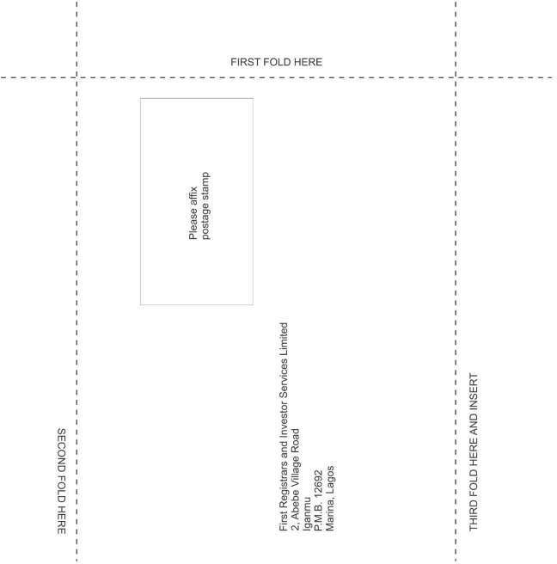


w w w. n b p l c . co m

